COVID – 19 VOSHA Training guide

After reading through the training materials at: <http://www.contactcommunications.com/assets/35527606e0/COVID_Training.pdf>

Please follow the link at the end:

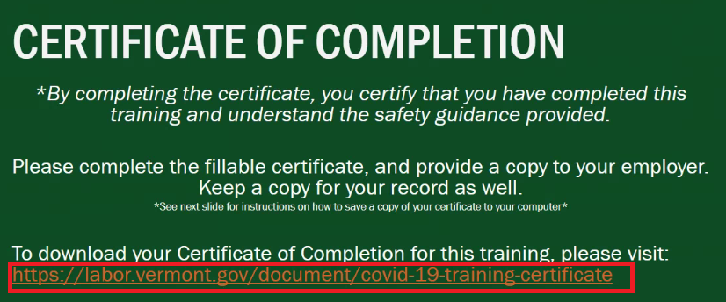

The link should open in the default web browser or the default PDF reader.

If it opens in a PDF reader and is blocked by “Safe Reading” settings Safe mode can be disabled under “Tools > Preferences > Trust Manager” and uncheck safe reading mode

Next open the self sign certificate:

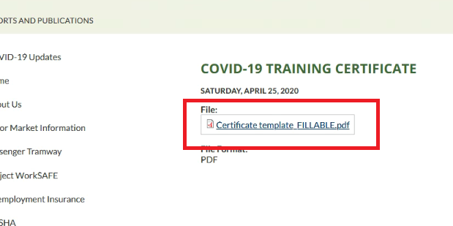

This will open in the browser window but will NOT be functional.

There should be an error message at the top, click on “Open with different viewer”:

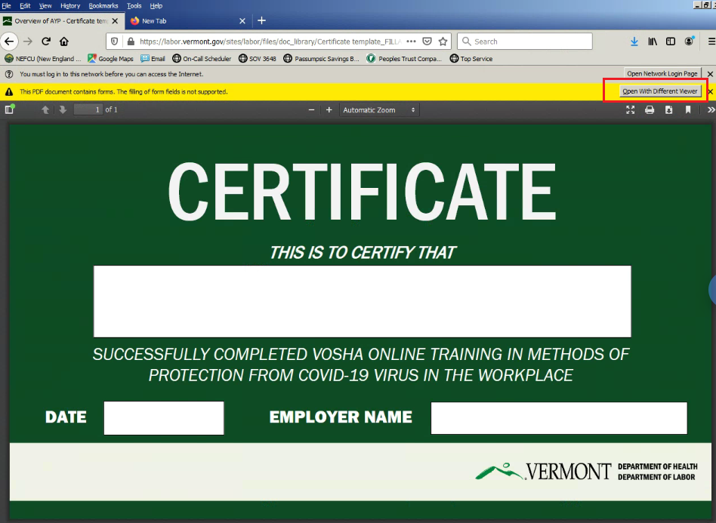

This will open a dialog to open the document in Adobe or Foxit:

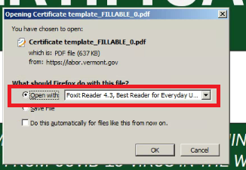

Edit the certificate to add Name, Date and Company Name.

If there is an error asking about an update it is safe to click “No” and continue

Save the certificate to your computer:

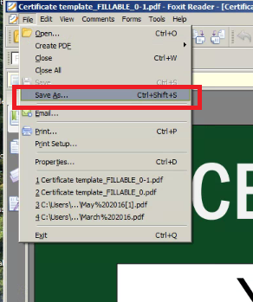

Finally, email the completed certificate to kp@contactbeep.com